C01 – ASSESSMENT TOOL OUTPUT PREDICTION
NAME : S.SHAMAH ALI FATHIMA
REG NO : 192573002
COURSE CODE : CSA0307
COURSE NAME : DATA STUCTURES
- WRITE A C PROGRAM FOR SEARCHING AN ELEMENT IN AN SORTED ARRAY

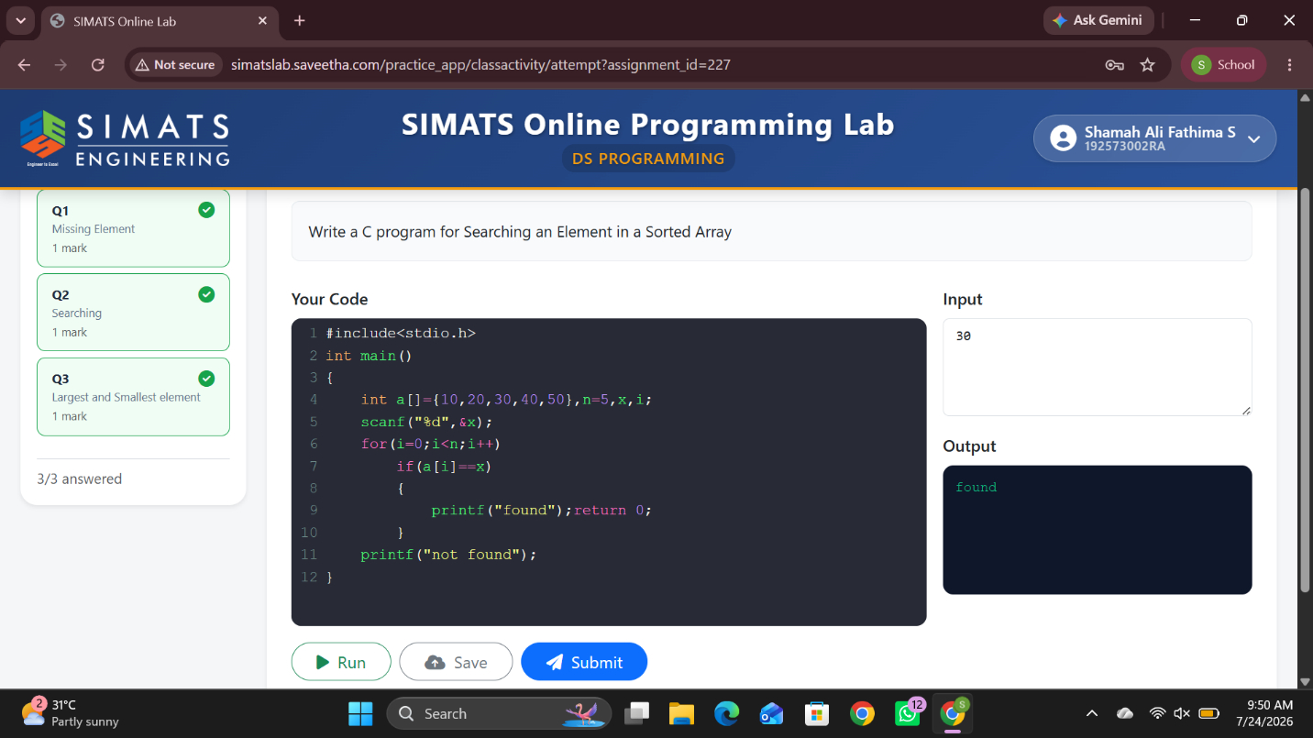

2)WRITE A C PROGRAM FOR MISSING ELEMENT IN AN ARRAY
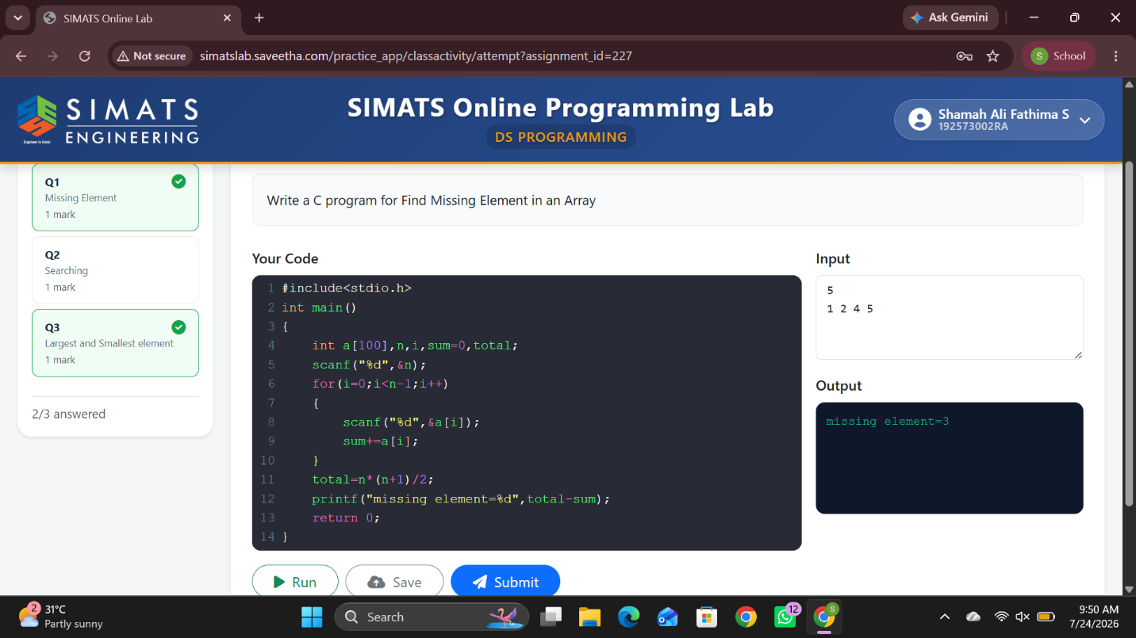

3)WRITE A C PROGRAM TO FIND THE LARGEST AND SMALLEST ELEMENT IN AN ARRAY
